Phase 6: Implement Client Script & UI Policy (Incident)
Project Testing Phase
1. Introduction
The Project Testing Phase is conducted to verify that the UI Policies and Client Scripts developed for the ServiceNow Incident Management module function according to the project requirements. Testing helps identify configuration errors, check conditional field behavior, validate automatic updates, and confirm that Incident records cannot be submitted or modified in ways restricted by the configured rules.
The main purpose of this phase is to ensure that the project works correctly under different conditions, including High Impact and Medium Impact Incidents, form submission, and list editing.
2. Objectives of Testing
The objectives of the testing phase are:
- To verify that the High Impact Control UI Policy is triggered when Impact is set to High.
- To confirm that Assignment Group becomes mandatory under the specified condition.
- To verify that Urgency becomes read-only when Impact is High.
- To test whether the onChange Client Script automatically sets Urgency to High.
- To verify that the onSubmit Client Script prevents submission when Assigned To is empty for High Impact Incidents.
- To confirm that the onCellEdit Client Script blocks direct State changes through list editing.
- To ensure that State can still be updated through the Incident form.

3. Testing Environment
Component | Description
Platform | ServiceNow
Application | Incident Management
Module | Incident
UI Policy | High Impact Control
UI Policy Action | Assignment Group and Urgency
Client Scripts | onChange, onSubmit, onCellEdit
Testing method | Manual functional testing
4. Functional Testing
Test Case 1: Mandatory Field Enforcement
Purpose: To check whether the Incident form enforces the required information when Impact is High.
Test procedure:
- Log in to the ServiceNow instance.
- Navigate to Incident → Create New.
- Set the Impact field to High.
- Leave the Assigned To field empty.
- Attempt to submit the Incident.
Expected result:
- The onSubmit Client Script should prevent the record from being saved.
- An error message should appear: Assigned To is mandatory for High impact incidents.
- The user should be able to correct the missing information before submitting.
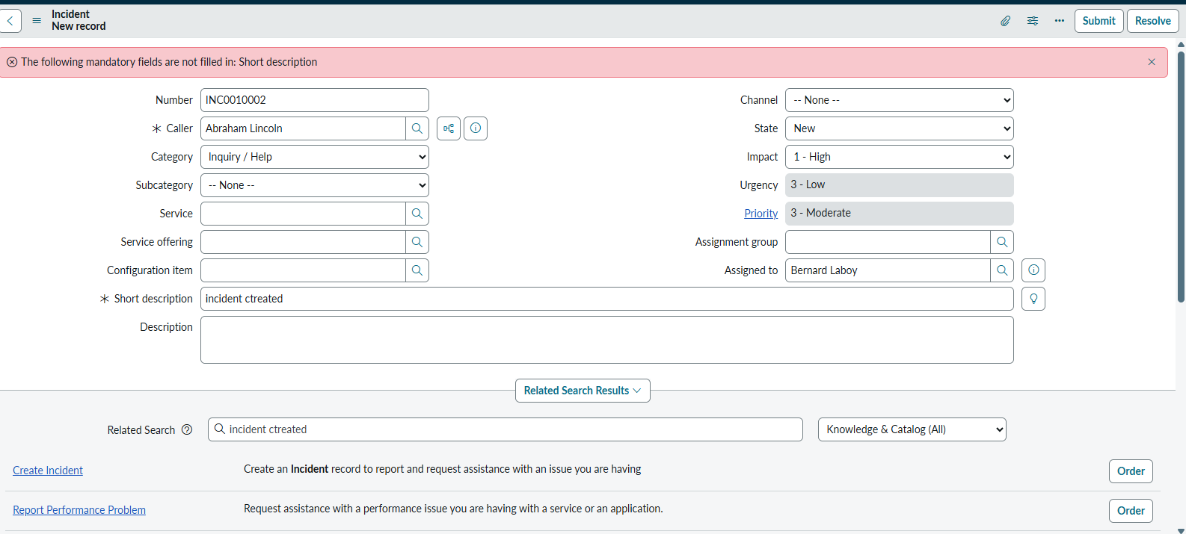
Expected behavior
Submission is blocked when the configured condition is met.
Test Case 2: Successful Incident Submission
Purpose: To verify that an Incident can be submitted when the required Assigned To information is provided.
Test procedure:
- Open a new Incident form.
- Set Impact to High.
- Select a user in the Assigned To field.
- Fill in any other required Incident fields.
- Click Submit.
Expected result:
- The onSubmit validation should allow the submission.
- The Incident should be saved successfully if all other platform requirements are satisfied.
- No missing Assigned To error should be displayed.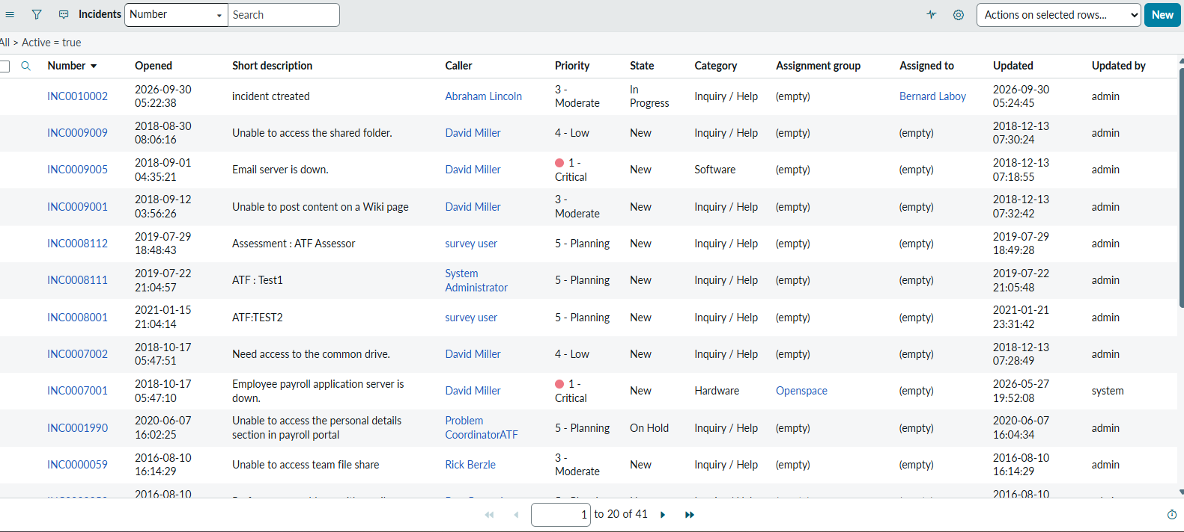
Test Case 3: UI Policy Activation
Purpose: To verify that the High Impact Control UI Policy is activated when Impact is High.
Test procedure:
- Open an Incident form.
- Set Impact to High.
- Observe the Assignment Group field.
- Check whether the field is marked mandatory.
Expected result:
- The High Impact Control UI Policy should apply.
- Assignment Group should become mandatory.
- The user should be required to provide the field value according to the configured UI Policy Action.
Test Case 4: Urgency Read-only Behavior
Purpose: To verify that the Urgency field becomes read-only for High Impact Incidents.
Test procedure:
- Open an Incident form.
- Change Impact to High.
- Observe the Urgency field.
- Attempt to change the Urgency value manually.
Expected result:
- Urgency should remain visible.
- Urgency should become read-only while Impact is High.
- The user should not be able to manually change the field while the UI Policy condition is true.
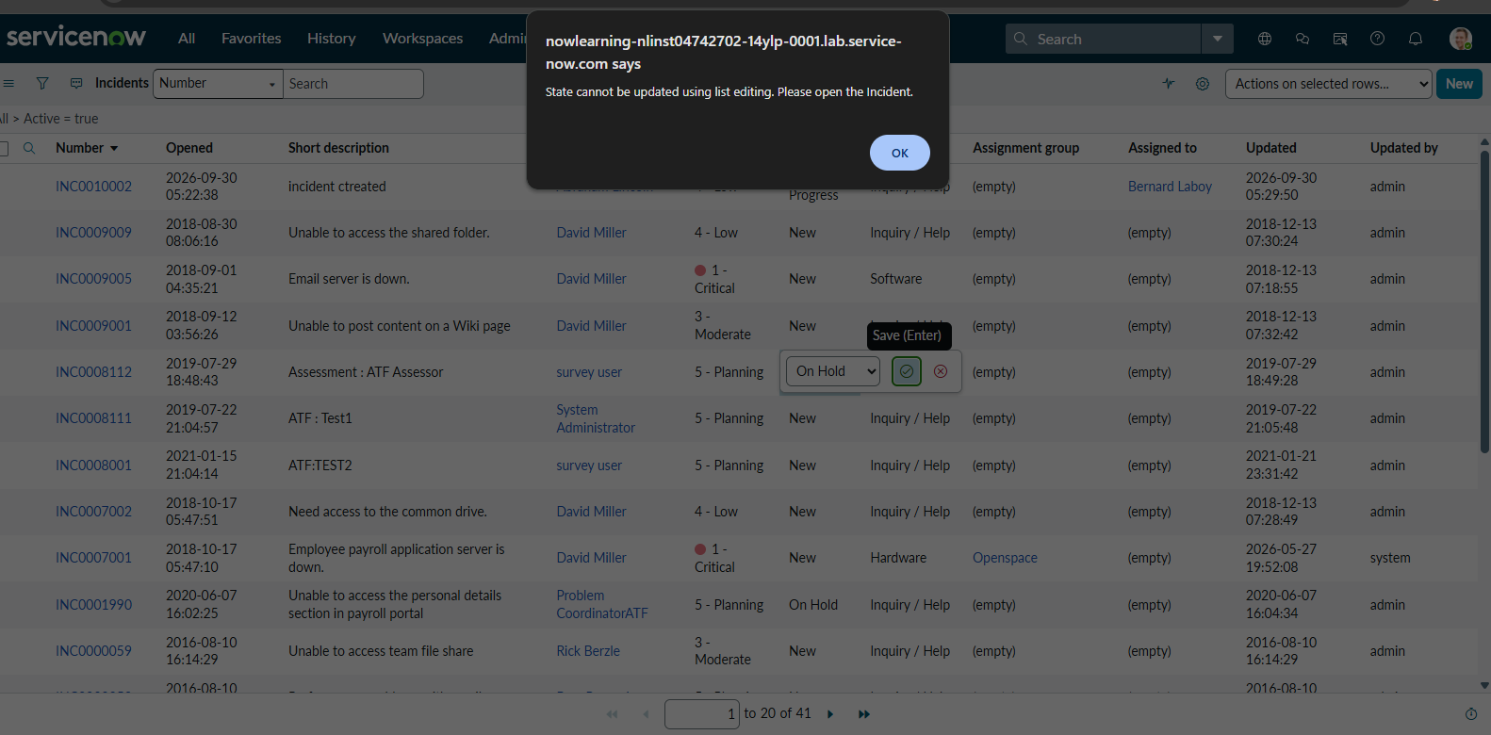
Test Case 5: Automatic Urgency Update
Purpose: To verify that the onChange Client Script automatically sets Urgency to High when Impact changes to High.
Test procedure:
- Open an Incident form.
- Change the Impact field to High.
- Observe the Urgency field.
- Check for the informational message.
Expected result:
- Urgency should automatically be set to High.
- The message Urgency set to High for High impact incident. should be displayed.
- The script should not perform the update while the form is loading or when the new Impact value is empty.
Test Case 6: Reverse Condition Testing
Purpose: To verify that the UI Policy actions are reversed when Impact is changed from High to Medium.
Test procedure:
- Open an Incident form where Impact is High.
- Change Impact to Medium.
- Observe Assignment Group and Urgency.
- Attempt to edit Urgency.
Expected result:
- Assignment Group should no longer be mandatory due to this UI Policy.
- Urgency should become editable again.
- The UI Policy should reverse its applied field changes when its condition becomes false.
Test Case 7: List Edit Blocking
Purpose: To verify that the onCellEdit Client Script prevents State changes through the Incident list.
Test procedure:
- Navigate to Incident → All.
- Locate an Incident record.
- Double-click the State field in the list.
- Attempt to change its value.
Expected result:
- An alert should appear: State cannot be updated using list editing. Please open the Incident.
- The callback should reject the list edit.
- The State value should remain unchanged.
Test Case 8: Form-based State Update
Purpose: To confirm that users can still change the State field through the Incident form.
Test procedure:
- Open an existing Incident record.
- Change the State field to a different value.
- Click Update.
- Reopen or refresh the record to verify the saved value.
Expected result:
- The State change should be saved successfully if the record meets the other applicable validation rules.
- The onCellEdit restriction should not block form-based updates.
- Other UI Policy and Client Script behaviors should remain active.
5. Test Case Summary
Test Case | Feature Tested | Expected Result
1 | Mandatory enforcement | Submission blocked if Assigned To is empty for High Impact
2 | Successful submission | Incident saves when required information is supplied
3 | UI Policy activation | Assignment Group becomes mandatory
4 | Urgency read-only | Urgency cannot be manually edited for High Impact
5 | Automatic update | Urgency is set to High
6 | Reverse condition | Mandatory and read-only changes are reversed
7 | List edit blocking | State change through list editing is rejected
8 | Form-based update | State can be changed through the form
7. Defect Identification and Correction
During testing, any behavior that differs from the expected result should be recorded as a defect. The following checks can help identify configuration problems:
- Assignment Group is not mandatory: Check the UI Policy condition, UI Policy Action field selection, and Reverse if false setting.
- Urgency does not become High: Check the onChange script type, Impact field selection, and the internal values used by the script.
- Incident saves without Assigned To: Check that the onSubmit script is active and that the field name is assigned_to.
- State changes through list editing: Check the onCellEdit script configuration, especially its table, type, and State field selection.
- Urgency remains read-only after Impact changes: Check the UI Policy's Reverse if false setting and its UI Policy Action.
A defect should be retested after correction to confirm that the expected behavior is restored.
8. Testing Limitations and Notes
The project uses client-side controls to guide and validate form interactions. Testing should be performed in the ServiceNow interface where these scripts and UI Policies are active.
The onSubmit script checks Assigned To, while the UI Policy makes Assignment Group mandatory. Both rules should be tested independently because they apply to different fields. Also, the onChange script sets Urgency to High, while the UI Policy makes Urgency read-only under High Impact; verify their interaction in the actual instance.
9. Conclusion
The Project Testing Phase verifies the behavior of the UI Policy and Client Scripts configured for Incident Management. The test cases cover mandatory field enforcement, successful submission, conditional field behavior, automatic Urgency updates, reverse conditions, list editing restrictions, and form-based State updates.
By executing and recording these tests, the project can demonstrate whether the implemented controls meet the specified requirements. The testing results also help identify and correct configuration errors, supporting consistent Incident data entry and reliable use of the ServiceNow platform.

